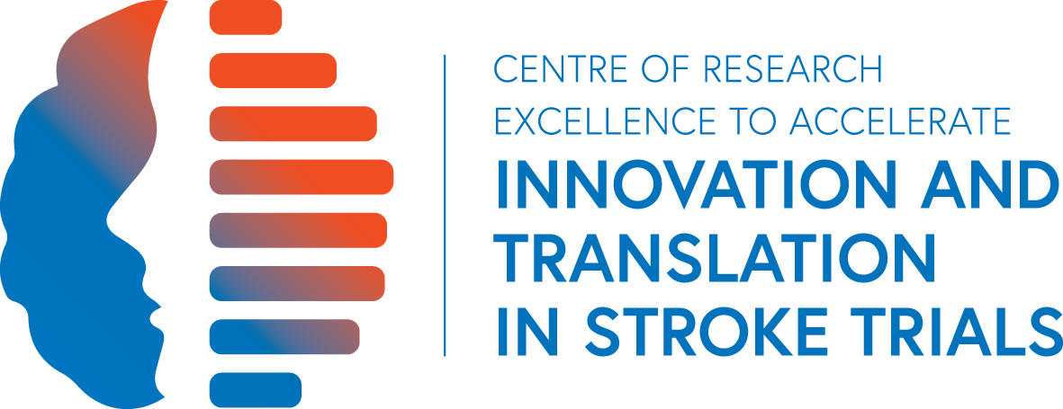

Research Affiliate Nomination Form

Family Name: |  |  |  |  | Given Name:
Best contact address:

Phone: |  |  | Fax: |  |  |  | Mobile:
Email:
Qualifications / Academic Background:

CRE Workstream/Theme/Main interests:

Project(s) Summary:
Current institution:
Supervisor:
Mentors:

Attach detailed CV
Other comments

Nominated by:  CRE Grant Holder | Name:
Signature: |  |  | Date:

Office use only:
Form received Date:
Acknowledgement email sent Date:

Please email/send to:

Program Manager
CRE To Accelerate Stroke Trial Innovation and Translation
Westmead Applied Research Centre
Block K, level 5
Westmead Hospital (C24)
University of Sydney
NSW2006
Stroke Trials CRE stroke-trials.cre@sydney.edu.au

